**Puzzle Maker 3**

* Features in Puzzle Maker 3
* Import settings for puzzle image
* Joints Mask Images
  + Rules for creating joint masks
* Puzzle Maker File Creator
* Prefabs Overview
  + Using Prefabs
* Example Scenes
* Hosting On Server
* Contact Me
* Scripts Abbreviations

Features in Puzzle Maker 3

Create different types of joints for pieces

Create custom joints designs for your puzzle pieces refer to Joint Mask Images.

Script randomly assigns different types of joints to pieces

  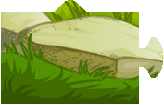

Save all generated data which can be used to recreate puzzle maker instance

Puzzle Maker can create file to save all the pieces created and all the necessary data required to recreate in a binary file so that you can update new puzzles to your game online and you don’t have to redo whole process of puzzle generation every time.

Puzzle maker file creator for exporting image of pieces or creating pm file

Refer to Puzzle Maker File Creator.

Two prefabs to create two different style of puzzle game

Puzzle maker provided two prefabs with example scenes to create two styles of puzzle game just by adding a prefab to your scene.

Import settings for puzzle image

There are some settings you need to change in image you want to use to create puzzle pieces. Select *texture type = Advanced* , *Non Power of 2 = None , Read/Write Enabled should be checked*. Below image shows the settings applied in the inspector for ease of understanding.

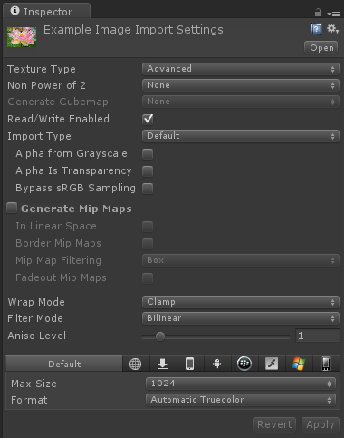

Joints Mask Images

Joint mask images are the images which are used to define the design of a joint. There are 6 different mask images are already included with the game which you can find in *PM Free Image->Joint* *mask* folder, below images shows the joint masks which are included with the package.

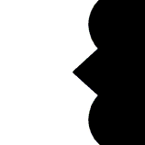

* + Rules for creating joint masks

There are rules that you need to follow to create your own joint mask images.

1. As you can see from above image your joint mask image should face towards left.
2. The area that needs to become joint should be black and other area should be white.
3. End of your joint mask image (Black area) should be connected to right side of the image i.e. there should be no white space between the end of joint mask image (Black area) and end of image at right side of image.
4. Joint Mask image width and height should be equal.

Puzzle Maker File Creator

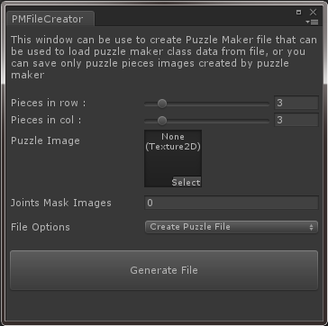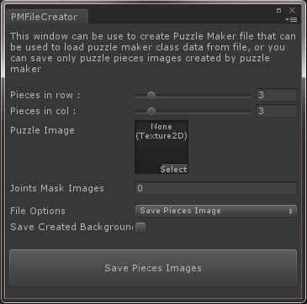

You can access Puzzle maker file creator from Window->Puzzle Maker -> CreatePMFile submenu.

In here you will have to provide pieces for your puzzle image that you imported to unity for puzzle using puzzle image import settings, provide joint mask images if you want to otherwise default circular joints will be made.

In File Options there are two options

* **Create Puzzle File**

Use to create puzzle maker file that you can choose in game prefabs to use for your puzzle.

* **Save Pieces Image**

Use this if you just want to create pieces images and store them to a location.

After providing all the options click on the button and it will ask you either folder for pieces images to be placed or filename for puzzle maker file creation.

Prefabs Overview

There are total of four prefabs provided in PM Prefabs folder. Every prefab have its own camera that is resized by puzzle maker to display whole puzzle inside screen regardless of puzzle size.

* **JigsawPuzzleJP**

Put this prefab in a scene and provide settings in the script named *JPPuzzleController* on running the game it will create a fully functional joint pieces style puzzle game for you by either loading data from pm file or creating everything at runtime from the puzzle image you provided.

You can change settings for this puzzle from JPPuzzleController script which is attached to JPPuzzle child of JigsawPuzzleJP.

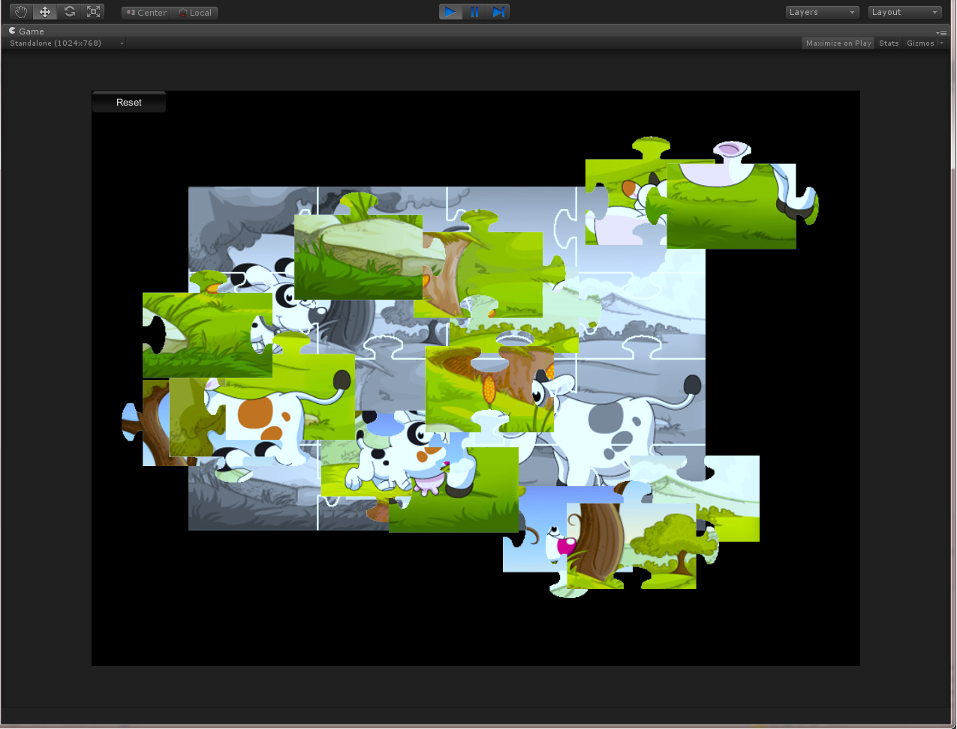

* **JigsawPuzzlePP**

Put this prefab in a scene and provide settings in the script named *PPPuzzleController* on running the game it will create a fully functional joint pieces style puzzle game for you by either loading data from pm file or creating everything at runtime from the puzzle image you provided.

You can change settings for this puzzle from PPPuzzleController script which is attached to PPPuzzle child of JigsawPuzzlePP.

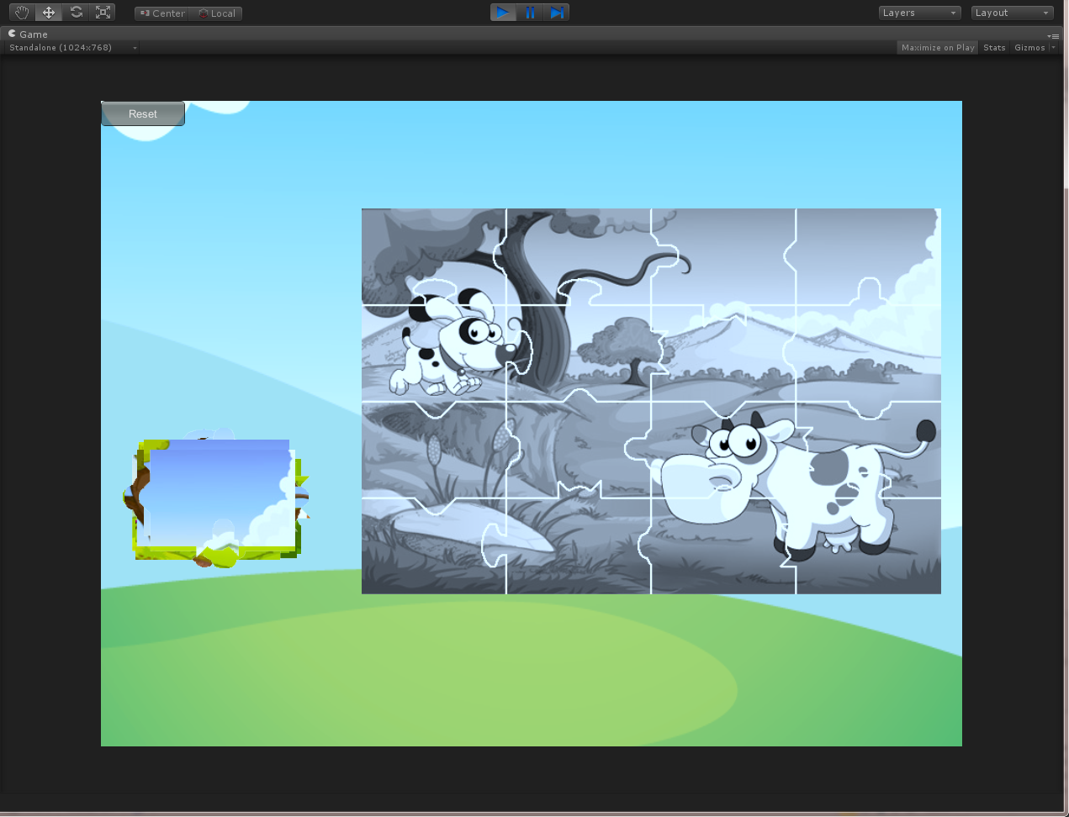

* **JigsawPuzzleSP**

Put this prefab in a scene and provide settings in the script named *SPPuzzleController* on running the game it will create a fully functional slide pieces style puzzle game for you.

You can change settings for this puzzle from SPPuzzleController script which is attached to SPPuzzle child of JigsawPuzzleSP.

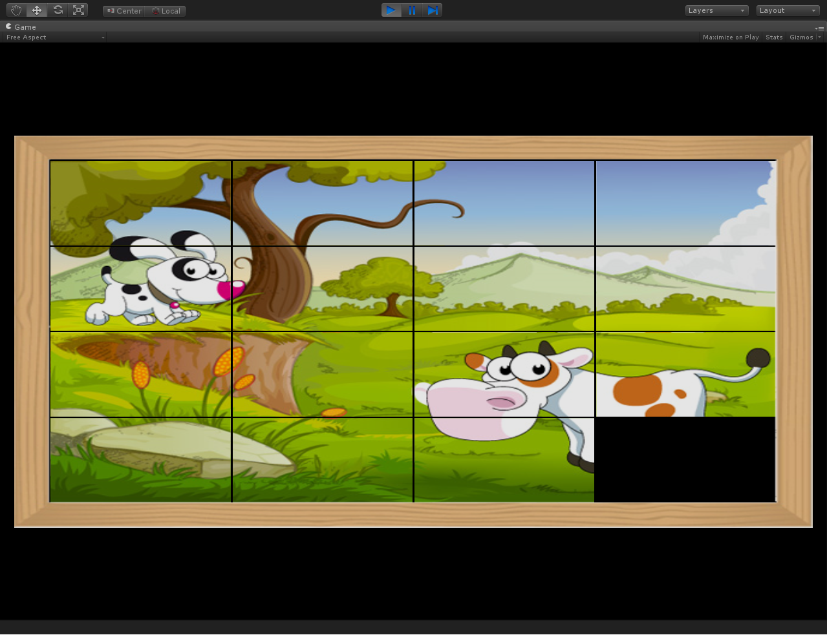

* **JigsawPuzzleMP**

Put this prefab in a scene and provide settings in the script named *MPPuzzleController* on running the game it will create a fully functional Memory puzzle game for you.

You can change settings for this puzzle from MPPuzzleController script which is attached to MPPuzzle child of JigsawPuzzleMP.

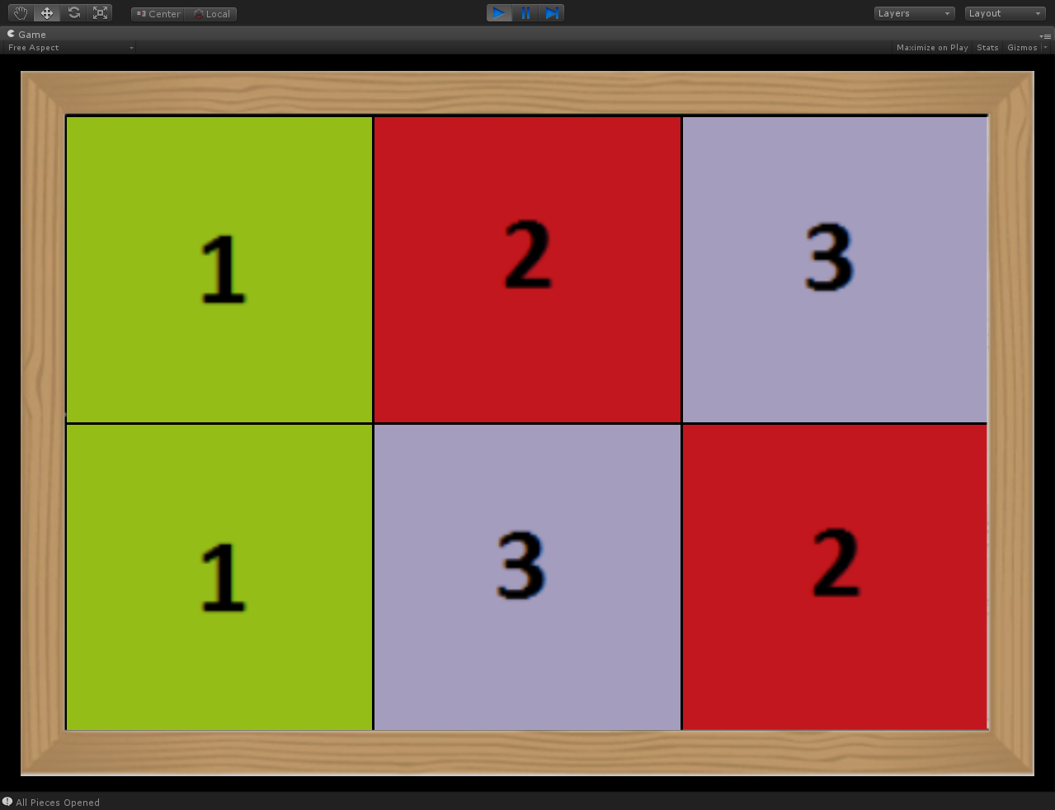

Example Scenes

Four example scenes in the package which shows working of two puzzle game style prefabs.

**PM Join Pieces Example**



**PM Pick And Place Example**



**PM Sliding Pieces Example**



**PM Memory Puzzle Example**



Hosting On Server

Puzzle Maker now supports web player build, the only thing you need to do for hosting is if you are using .pm files to load puzzles from you will have to upload streaming assets folder which is containing .pm files, you will have streaming assets folder available at the path where you build for web player, Puzzle Maker downloads and uses .pm files from streaming assets folder only, if you want to download from any other folder you can put that folder and make appropriate changes in PuzzlePieceMaker.cs script under LoadData() function.

Script Abbreviations

|  |  |
| --- | --- |
| **Abbreviation** | **Description** |
| JP | Join Pieces |
| MP | Memory Puzzle |
| PP | Pick And Place |
| PM | Puzzle Maker |

If you have any suggestions or problems you can email me at [m_umair69@yahoo.com](mailto:m_umair69@yahoo.com)